Reigns All Over

GGD Kind of documentation

Summary:

Reigns All Over is a fantasy RPG style prototype similar to games like the Witcher & Elder scrolls series. It an attempt at recreating gameplay features such as fighting enemies, quest system, dialogue, NPC Behavior & character development.

All assets such as character models and animations free ones taken from the asset store and Mixamo. All programming is done by me for learning purposes and will only refer to other works. I did not use anyone else’s scripts as a base.

Section: Player

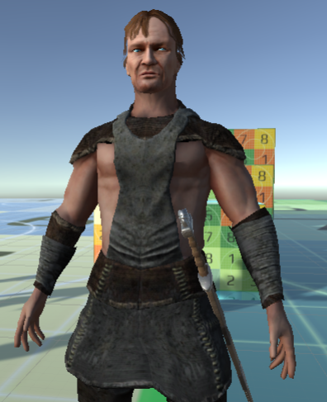

Allenran ‘Andan’ Aughmas 🡪 Temporary name

Allenran is a adventurer with the fighting style that of a spellsword.

He has two types of sword attacks: Light & Heavy.

* Light attacks 🡪 Deal less damage but are fast, cost no stamina.
* Heavy attacks 🡪 Deal even more damage, more likely to cause critical damage but will consume stamina and are slower.

He can block incoming damage with a certain damage percentage reduction. This reduction % will vary according to player skill. Block stun & reposte attack can be a skill.

He can use his spare left arm for casting spells. Allenran will not be a fully trained mage in the beginning, but he can be developed in such skill.

Skill Trees & Character Development:

Main skill trees:

1. Combat
2. Agility

Combat

* General
* Dodging